CODING ACTIVITY 3.1 SOLUTION

Task

Given the following 6 empty functions, go through each comment, and complete the code to return the proper array on each of them.

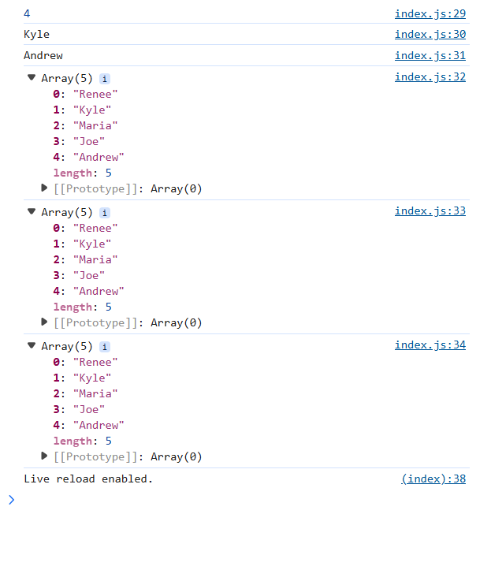

Task

Given an array of strings called words, return a string that has all the words concatenated together.

